11.6 Making salts
Name: ____________________ Class: ____________________ Due date:
1. Which of these pairs of aqueous ions both react with dilute sulfuric acid to give a visible result? （ ）
A Ba²⁺ and Cl⁻
B Ba²⁺ and CO₃²⁻
C NH₄⁺ and Cl⁻
D NH₄⁺ and CO₃²⁻

2. Aqueous sodium hydroxide is added to solid X and the mixture is heated.
A green precipitate is formed and an alkaline gas is given off.
Which ions are present in X? （ ）
A NH₄⁺ and Fe²⁺
B NH₄⁺ and Fe³⁺
C OH⁻ and Fe²⁺
D OH⁻ and Fe³⁺

3. How many different salts could be made from a supply of dilute sulfuric acid, dilute hydrochloric acid, copper, magnesium oxide and zinc carbonate? （ ）
A 3 B 4 C 5 D 6

4. Which salt preparation uses a burette and a pipette? （ ）
A calcium nitrate from calcium carbonate and nitric acid
B copper(II) sulfate from copper(II) hydroxide and sulfuric acid
C potassium chloride from potassium hydroxide and hydrochloric acid
D zinc chloride from zinc and hydrochloric acid

5. Four steps to prepare a salt from an excess of a solid base and an acid are listed.
1 crystallisation
2 evaporation
3 filtration
4 neutralisation
In which order are the steps carried out? （ ）
A 2→3→4→ 1
B 3→1→2→4
C 4→2→1→3
D 4→3→2→1

6. Which method is used to make the salt copper sulfate? （ ）
A dilute acid + alkali
B dilute acid + carbonate
C dilute acid + metal
D dilute acid + non-metal oxide

7. Which of the following methods are suitable for preparing both zinc sulfate and copper sulfate? （ ）
1 Reacting the metal oxide with warm dilute aqueous sulfuric acid.
2 Reacting the metal with dilute aqueous sulfuric acid.
3 Reacting the metal carbonate with dilute aqueous sulfuric acid.
A 1 and 2 only
B 1 and 3 only
C 2 and 3 only
D 1, 2 and 3

8. Which two compounds give a white precipitate when their aqueous solutions are mixed? （ ）
A silver nitrate and sodium chloride
B silver nitrate and sodium iodide
C sodium hydroxide and copper(II) sulfate
D sodium hydroxide and iron(II) chloride

9.Four stages in the preparation of a salt from an acid and a solid metal oxide are listed.
1 Add excess solid
2 Evaporate half the solution and leave to cool.
3 Filter to remove unwanted solid.
4 Heat the acid.
In which order should the stages be carried out? （ ）
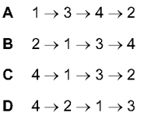

10. Zinc sulfate is a soluble salt and can be prepared by reacting excess zinc carbonate with dilute sulfuric acid.
Which piece of equipment would not be required in the preparation of zinc sulfate crystals? （ ）
A beaker
B condenser
C evaporating dish
D filter funnel

11. A salt is produced in each of the following reactions.
P magnesium + dilute hydrochloric acid
Q zinc oxide + dilute sulfuric acid
R sodium hydroxide + dilute hydrochloric acid
S copper carbonate + dilute sulfuric acid
Which statements about the products of the reactions are correct? （ ）
1 A flammable gas is produced in reaction P.
2 Water is formed in all reactions.
3 All the salts formed are soluble in water.
A 1, 2 and 3 B 1 and 2 only C 1 and 3 only D 2 and 3 only

12. Silver chloride is insoluble in water and is prepared by precipitation.
Which two substances can be used to make silver chloride? （ ）
A barium chloride and silver nitrate
B hydrochloric acid and silver
C hydrochloric acid and silver bromide
D sodium chloride and silver iodide

13. Dilute sulfuric acid is added to two separate aqueous solutions, X and Y. The observations are shown.
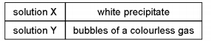
Which row shows the ions present in the solutions? （ ）
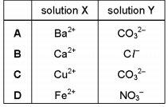

14. Zinc sulfate is made by reacting an excess of zinc oxide with dilute sulfuric acid.
The excess zinc oxide is then removed from the solution.
Which process is used to obtain solid zinc sulfate from the solution? （ ）
A crystallisation
B dissolving
C filtration
D fractional distillation

15. Compound P reacts with hydrochloric acid to produce a gas that turns limewater milky.
What is P? （ ）
A sodium carbonate
B sodium chloride
C sodium hydroxide
D sodium sulfate

16. Which ion forms a green precipitate with aqueous sodium hydroxide that dissolves in an excess of aqueous sodium hydroxide? （ ）
A ${\text{Ca}}^{2+}$
B ${\text{Cr}}^{3+}$
C ${\text{Cu}}^{2+}$
D ${\text{Fe}}^{2+}$

17. The solubility of some salts is shown:
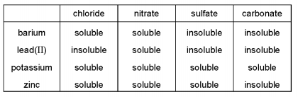
Which two aqueous solutions produce an insoluble salt when mixed together? （ ）
A barium chloride and zinc nitrate
B barium nitrate and lead(I) nitrate
C lead(II) nitrate and potassium carbonate
D potassium nitrate and zinc sulfate

18. An excess of aqueous sodium sulfate was added to aqueous barium chloride and the mixture was filtered. （ ）
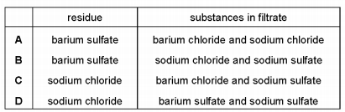
19. Which methods are suitable for preparing both zinc sulfate and copper(II) sulfate? （ ）
1 reacting the metal oxide with warm dilute aqueous sulfuric acid
2 reacting the metal with dilute aqueous sulfuric acid
3 reacting the metal carbonate with dilute aqueous sulfuric acid
A 1, 2 and 3
B 1 and 2 only
C 1 and 3 only
D 2 and 3 only
20. When dilute sulfuric acid is added to solid X,a colourless solution is formed and a gas is produced.
What is X? （ ）
A copper(Il) oxide
B sodium oxide
C copper(ll carbonate
D sodium carbonate

21. A white precipitate is produced when small amounts of two colourless solutions are mixed together. Which pairs of solutions produce a white precipitate? （ ）
1 sodium hydroxide and zinc nitrate
2 sodium hydroxide and aluminium chloride
3barium chloride and sulfuric acid
4 acidified barium nitrate and potassium sulfate
A 1,2,3and 4 B 1,2and 4 only C 1and 2 only D 2only

A few drops of methyl orange are added to a reaction mixture. During the reaction, a gas is produced and the methyl orange turns from red to orange
What are the reactants?
A aqueous sodium hydroxide and ammonium chloride
B aqueous sodium hydroxide and calcium carbonate
C dilute hydrochloric acid and magnesium
D dilute hydrochloric acid and aqueous sodium hydroxide

Some general rules for the solubity of saits in water are listed.
Carbonates are insoluble (except ammonium carbonate,potassium carbonate and sodium carbonate).
Chlorides are soluble (except lead(I) chloride and silver chloride). ·Nitrates are soluble.
Sulfates are soluble (except barium sulfate,calcium sulfate and lead(l) sulfate) Which substances produce an insoluble salt when aqueous solutions of them are mixed?
A barium chloride and magnesium nitrate
B calcium chloride and ammonium nitrate
C siver nitrate and zinc chloride
D sodium carbonate and potassium sulfate

Which type of oxide are carbon monoxide and aluminium oxide?
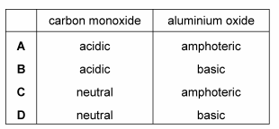
Which statement about carbon monoxide and aluminium oxide is correct?
A Both are amphoteric
B Both are neutral
C CO is amphoteric but Al₂O₃ is neutral
D CO is neutral but Al₂O₃ is amphoteric

Which substance is a neutral oxide?
A aluminium oxide
B carbon monoxide
C sulfur dioxide
D zinc oxide

A method to make copper(II) sulfate crystals:
- Place dilute sulfuric acid in a beaker
- Warm the acid
- Add copper(II) oxide until excess
- Filter the mixture
- Evaporate filtrate until crystals form
- Leave to cool
What are the purposes of step 3 and step 4?
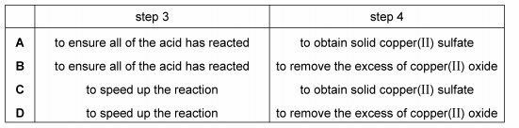

Lead(ll) sulfate is an insoluble salt.
Which reaction produces a mixture from which lead(ll) sulfate is obtained by filtration?
A crystallisation
B drying
C filtration
D precipitation

$${\text{Pb(NO}}_{3}{\text{)}}_{2}(aq)+2NaI(aq)→{\text{PbI}}_{2}(s)+2{\text{NaNO}}_{3}(aq)$$
How to separate lead(II) iodide?
A crystallisation
B distillation
C evaporation
D filtration

Which reaction produces filterable lead(II) sulfate?
A PbCO₃(s) + H₂SO₄(aq)
B Pb(OH)₂(s) + H₂SO₄(aq)
C Pb(s) + H₂SO₄(aq)
D Pb(NO₃)₂(aq) + H₂SO₄(aq)

The apparatus shown is used to prepare aqueous copper(ll) sulfate.
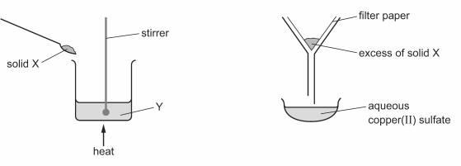
What are X and Y?
